Computer Vision Final project report

Human face recognition and detection using deep learning

Shuyan Li

9398959

The final project for computer vision is about deep learning. I didnt use some tools for deep learning like CNN, CAFFE. Instead, I just use MATLAB and try to implement this project by reading some paper as well as some examples.

First thing I want to decide is what kind of database do I want to use for the project. The professor provides an example of car recognition. But I want to build something that could be useful in real life. So I decided to see if I can build a program that can detect and recognize a person’s face given a large database.

I found a website called eigenface system so all my implementation is based on this idea. It uses principal components analysis (PCA). The corresponding paper I use to guild me is here: <http://www.face-rec.org/algorithms/PCA/jcn.pdf>

I found the database here: <http://www.cl.cam.ac.uk/research/dtg/attarchive/facedatabase.html>. It contains 400 pictures with 10 people with different expressions. We can recognize by our naked eye that they belong to 10 different people, despite that they all have different expressions.

First, I randomly pick an image from the database and use the rest of the images for training. Training is done on 399 pictures. I later use the randomly selected pictures to test the algorithm. As introduced in the paper, I set 20 signiture for each image. I subtract mean from the training set and I calculating eigenvectors of the correlation matrix. I pick the signature of the images and calculate the eigenvectors corresponding to the 10 largest eigenvalues. Then I calculate the signature for each image and I use these signatures to do the recognition.  
   
 For this program, first run the load_database.m to load the database in the folder to use for training(here s1 to s40). Then run the face_recognition.m to go through the deep learning.

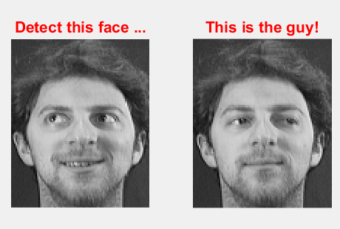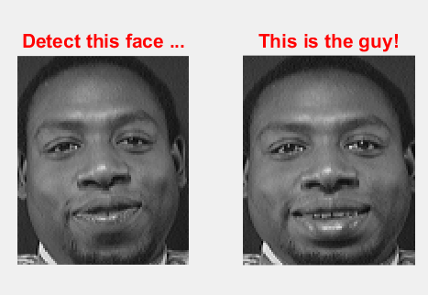

The program is working well, I test the program 50 times. I got 45 correct result and 5 wrong results, as shown above.

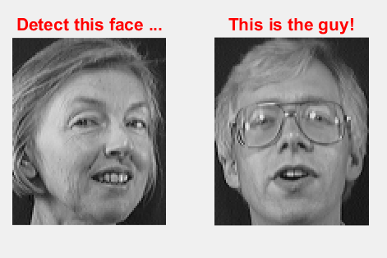

**wrong results. I think the program cannot detect this face since the target image has a side face so the Signature is not well detected and recognized.**

Lesson learned:

This is the first time I use deep learning. Its all hard for me. But I learned how to use internet resource to help me. I read several papers and try some existing codes. But they all work not quite well. I tried to implement the whole program step by step. Like how to load the database, how to determine the feature extractor, how to do the training, how to find the feature from the database. Etc. I will say this is a very interesting experience as a individual research based project.

Moreover, I tried to modify the program to make the accuracy better. Initially its not working good since I set the signature value too small. So it gives me lots of error detection. I also got some confusion on what feature do I extract. But I got inspired after reading the paper and checked some example code.

**Conclusion:**

This project teach me how to use deep learning. I also checked some deep learning and machine learning method like CNN and CAFFE. But its difficult to handle these tools in only two weeks. The PCA algorithm I used in this project work pretty well. The recognition rate is much higher then I thought, around 90% (based on 50 experiments). In future work, I will keep optimize the algorithm and see if I can handle it on CNN to make it a better recognition rate.